Deliverable A-Design Document

1.Web application topic

The topic for this web application is a Pet Adoption Service.

People who enter the website will be able to find a variety of pets(dogs and cats) that are currently in need of a welcoming home.

2.Target Audience

The people who will be interested in the subject of this website will have the following characteristics:

* The age range will be between 16-70
* The gender mix will be 50% men and 50% women
* They have the residence in Netherlands
* The level of education may vary
* They can be high-school, university students, employees or retirees
* They may use laptops, computers or smart devices (phones, tablets) to access the web

Fictional visitors:

**Name**  Dylan John Barbara

**Gender**  M M F

**Age**  17 30 60

**Location**  Eindhoven Amsterdam Tilburg

**Occupation**  Student Teacher Retired

**Income**  10 k 70k 80k

**Web Use** Daily 4-5 days/week 2-3 days/week

Main goals and motivations of users when visiting the website:

* They need to achieve a personal goal,that being to find a pet of their preference to adopt
* They want general information about the company who is in charge of the adoption service and specific information about each pet available in shelters
* They may desire to contact the staff in person (opening hours,address) or via email or phone for more details
* They need to make an appointment in case they find an ideal match and want to adopt

3.Sitemap

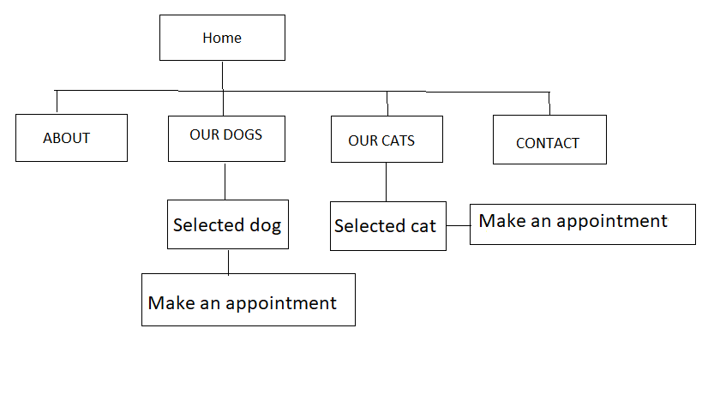

4.WireFrame

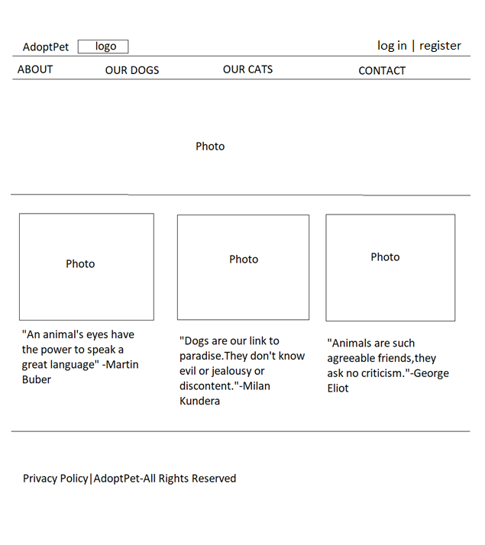

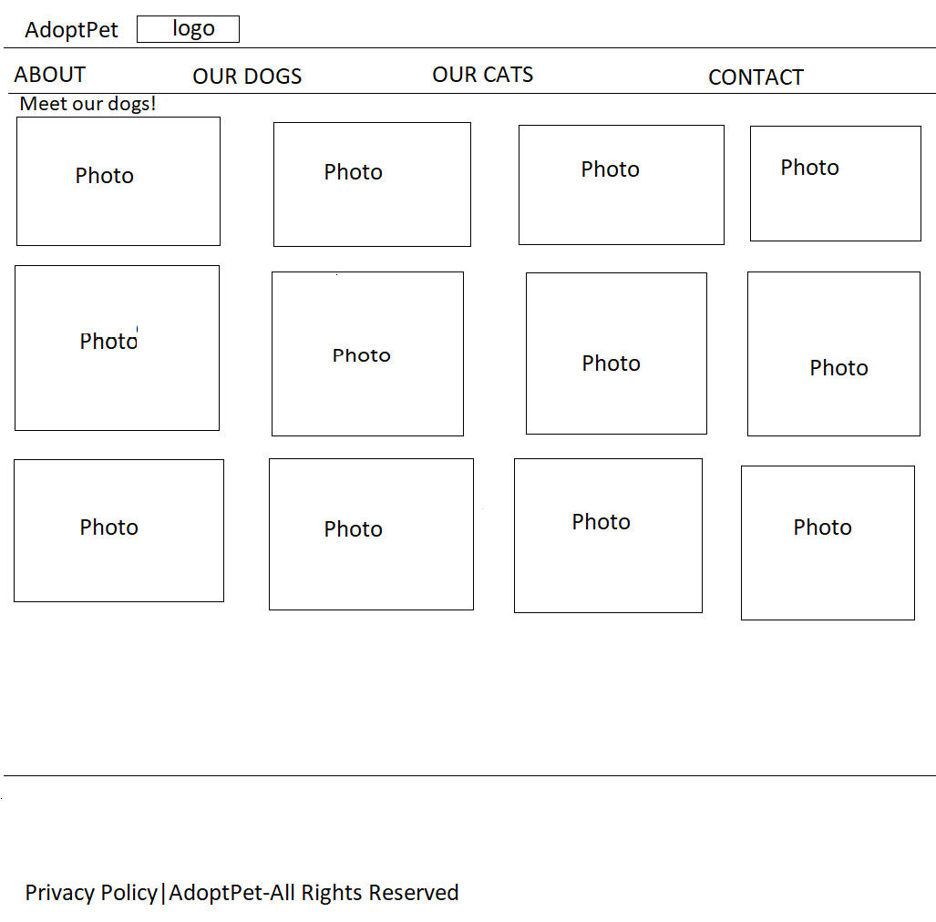

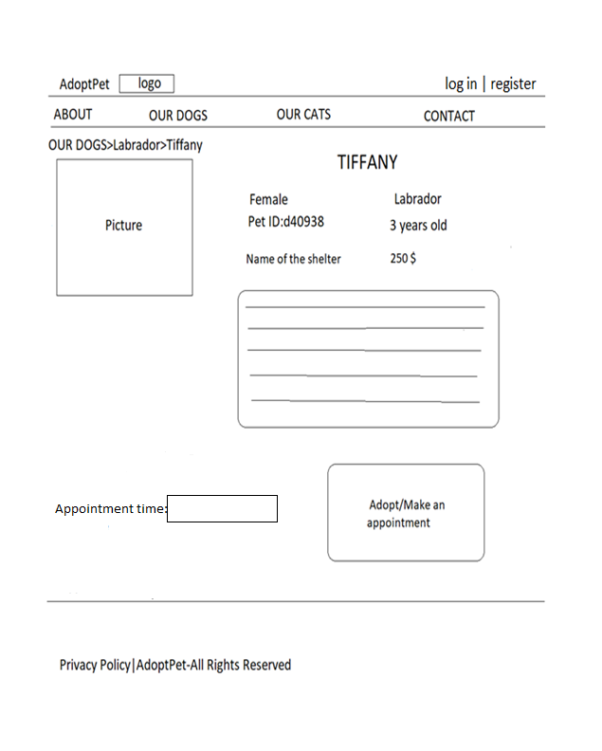

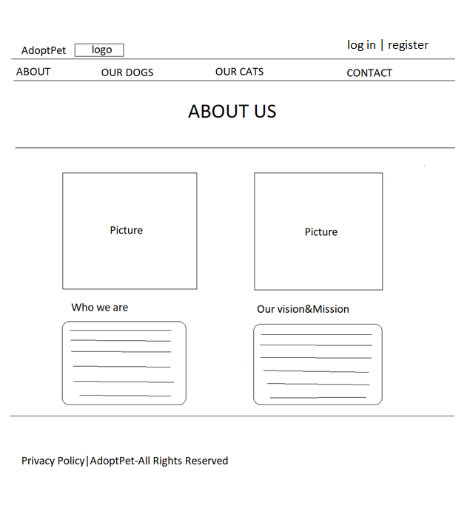

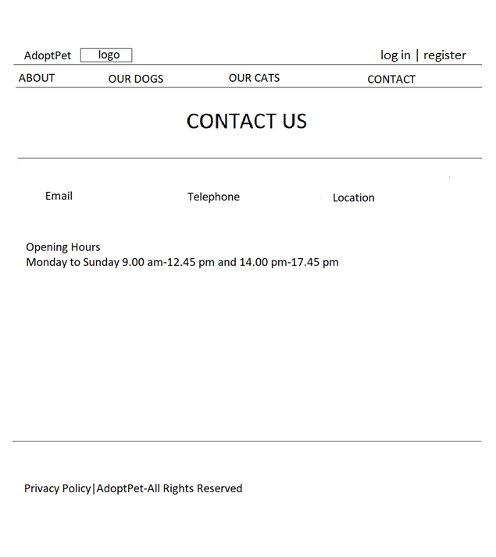

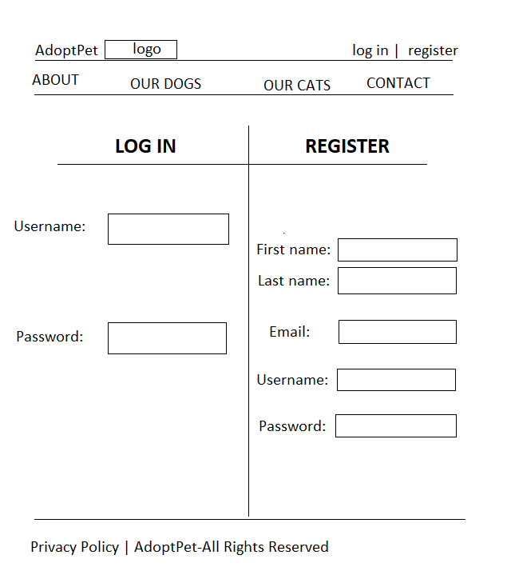

5.Design Document

